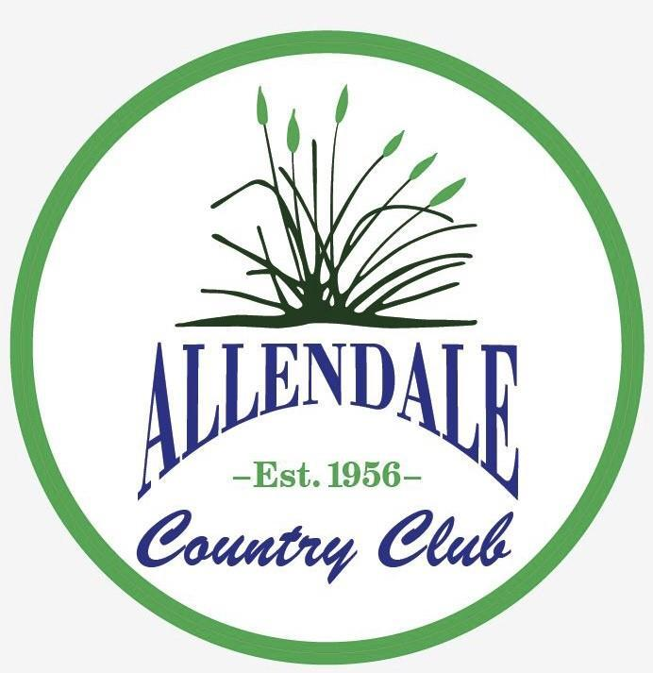

2021 EVENT CONTRACT

We are most pleased that you have selected Allendale Country Club as the site for your next event! We are certain that you will find our professional staff and overall amenities will exceed your every need.

This contract provides you with a step by step process to ensure that every detail is considered for your event. It is just as important to us that you have a successful Event. Please complete this contract in its entirety so that all of your needs and requests are met.

About Us

Allendale Country Club was established in 1956, the Club boasts a Geoffrey Cornish designed 18 Hole par 72 championship layout. The course offers a fair but challenging course for the beginner as well as the advanced golfer. In addition to the golf course itself, Allendale offers its members a host of other amenities. Included with all memberships is the use of the driving range, chipping green, practice green, and locker rooms. According to our community of reviewers, we are one of the best courses to play. Allendale Country Club has been rated #6 in Massachusetts for the Best of 2018 golf courses by GolfAdvisor.

At The Dale, We have a rustic style bar and restaurant open to the public!

We have outdoor seating and even have an outdoor lounge area for the warm seasons!

Spontaneously we plan exciting activities such as live bands, trivia, karaoke, bingo and many more!

Event Terms and Conditions

PAYMENT

In order to reserve the date and time indicated above, I understand and by my signature on this Contract, hereby agree to the following terms:

This Event Contract must be signed and returned with a $200.00 DEPOSIT to formally secure the requested outing date. This deposit can be paid with cash, corporate check or credit card. Please make checks payable to Allendale Country Club. (NOTE: This deposit will be applied against the final bill)

The FINAL GUARANTEE for all guests, must be due 7 (seven) days prior to the event date. The guaranteed number is not subject to reduction. Events with fewer than the guaranteed number of guests will be charged for the final guaranteed number.

The FINAL BALANCE must be paid in full no later than the end of day on the event date. This amount can be paid with cash, corporate check or credit card. Please make checks payable to Allendale Country Club.

FOOD AND BEVERAGE

All food and beverages must be purchased from the food and beverage cart at Allendale Country Club or The Dale (Restaurant). Any outside catering requests must be approved by our staff in advance.

Alcoholic beverages/food concessions: it is a violation of Allendale Country Club's liquor license to bring alcohol purchased elsewhere onto the property. We will cooperate in strictly enforcing these regulations. No personal coolers are allowed on the premise.

INDEMNIFICATION

Client hereby jointly and severally agrees to indemnify, defend and hold Allendale Country Club, harmless from all claims, suits, actions at law, judgments, liabilities, losses and damages (including attorney’s fees) arising from the use of Allendale Country Club Course property, however caused, including without limitations, any injury or damages resulting from negligent, careless, improper or unlawful conduct.

CANCELLATION POLICY

Allendale Country Club Country Club prides itself in planning and facilitating professional events for all groups. In most cases, our staff maintains schedules well in advance of association or group commitment dates. In the event of a cancellation, it is unlikely another group can fulfill these dates, especially if cancelled close to the actual event date. To partially recognize lost time it is agreed the following terms will be enforced:

Cancellation within 60 days of event – 100% of deposit will be refunded

Cancellation between 30 -60 days of event – 50% of deposit will be refunded

Cancellation within 29 days or less of event – 0% of deposit will be refunded

NOTE: The above terms will apply to cancelled events only but not rescheduled events occurring in the same year.

It is the sole discretion of Allendale Country Club to determine if weather is cause for cancellation on the day of the event. If, in our opinion, an event must be cancelled you will have the option to schedule another day.

DAMAGES

We assume all responsibility for any and all physical damage to the facility and/or equipment and for any personal injury to guests and employees of Allendale Country Club caused by our acts, conduct, or omissions or the acts, conduct or omissions of our guests. We acknowledge that Allendale Country Club is not responsible for items left on the premises from events or event participants. We acknowledge that as the undersigned, we assume all risks attendant with the operation of the golf carts, including responsibility for any and all damage caused to said cart due to negligent use of operation of the same. We will not allow children under the age of 18 to drive a golf cart.

Event Information

Official Event Title: _Click or tap here to enter text.

Contact Name: Click or tap here to enter text.

Address: Click or tap here to enter text.

Phone: Click or tap here to enter text.Email: Click or tap here to enter text.

Tax Exempt ID #:Click or tap here to enter text. (must attach tax exempt certificate)

Estimated # of People:Click or tap here to enter text.

PLEASE SELECT YOUR REQUESTED DAY AND START TIME

Day of Week Requested:

☐ Monday ☐Tuesday ☐ Wednesday ☐ Thursday ☐ Friday ☐ Saturday ☐ Sunday

Starting Times: ☐ AM ☐PM

Event Date (1st Choice): Click or tap to enter a date. 2nd Choice: Click or tap to enter a date.

Food and Beverage Information

*Please Select*

☐ Breakfast Buffet 14
Scrambled Eggs, Bacon, Sausage, Home Fries, Assorted Danishes, and Assorted Muffins. Juice, Tea & Coffee Station.

☐ Deluxe Breakfast Buffet 17
Scrambled Eggs, Bacon, Sausage, Home Fries, Linguica Hash, French Toast, Fresh Fruit, Assorted Danishes, and Assorted Muffins. Juice, Tea & Coffee Station.

☐ Brunch Buffet 18
Scrambled Eggs, Bacon, Sausage, Home Fries, Fresh Fruit, Assorted Danishes, Assorted Muffins, Chicken Parm and Baked Ziti. Juice, Tea & Coffee Station.

☐ Deluxe Brunch Buffet 23
Scrambled Eggs, Bacon, Sausage, Home Fries, Linguica Hash, French Toast, Fresh Fruit, Assorted Danishes, Assorted Muffins, Steak Tips, Lasagna, Seasonal Vegetables and Rice Pilaf. Juice, Tea & Coffee Station.

☐ Lunch Buffet 19
Assorted Mini
Sandwiches, Meatball Marinara, Buffalo Chicken Mac & Cheese. Choice of Pasta or Potato Salad. Dessert Station. Coffee & Tea Station.

☐ Deluxe Lunch Buffet 20
House or Caesar
Salad, Bake Ziti, Chicken & Broccoli Alfredo. Choice of Pasta or Potato Salad. Dessert Station. Coffee & Tea Station

☐ Dinner Buffet 22
Soup, House or Caesar Salad, Assorted Mini Sandwiches, Lasagna, Chicken Parm, Vegetable Medley, Rice Pilaf. Dessert Station. Coffee & Tea Station

☐ Deluxe Dinner Buffet 25
Soup, House or Caesar Salad, Assorted Mini Sandwiches, Lasagna, Lemon Pesto Chicken, Shrimp Mozambique, Vegetable Medley, Rice Pilaf. Dessert Station. Coffee & Tea Station

*Additional offerings available upon request and approval*

Estimated #Click or tap here to enter text.

Seating Preference for food service

☐ Indoor ☐ Outdoor

Total food and beverage costs are based on menu selections. Please specify with a server if there are any food allergies. Food and Beverage Purchases subject to 7% Sales Tax and 20% gratuity fee.

CONDITIONS OF THE AGREEMENT

Performance of the agreement is contingent upon the ability of Allendale Country Club management to complete the same, and is voidable in the event of labor dispute or strikes, accidents, government (Federal, State, or Municipal) requisitions, restrictions on travel, transportation, food, beverages, or supplies, and or other causes, whether enumerated herein or not, beyond the control of Allendale Country Club, preventing or interfering with the delivery of services required for the private function. In no event shall Allendale Country Club be held liable for other damages.

Event terms and conditions agreed to:

Signature below indicates that I/we fully consent with all of Allendale Country Club event terms and conditions including, but not limited to: Payment, guest count, food and beverage, and cancellation policies.

Client Signature: Click or tap here to enter text.Date: Click or tap here to enter text.

Printed Name: Click or tap here to enter text.Date: Click or tap here to enter text.

Allendale Country Club Signature: Click or tap here to enter text.

Printed Name: Click or tap here to enter text.

ALL CHECKS ARE TO BE MADE PAYABLE TO: ALLENDALE COUNTRY CLUB

1047 Allen Street, North Dartmouth, MA 02747 508-992-8682 www.allendalecc.net

